Bug Report: #402 – Checkout Crash with Promo Codes
Summary: Checkout page crashes with a 500 error when submitting payment using a valid promo code.

1. Environment
- Device/Platform: Windows 11, Desktop
2. Severity & Priority
- Severity: Mild (The search by stock button doesn’t work)
- Priority: Medium (Doesn’t impact too much but people might get mad since it crashes the program)
3. Steps to Reproduce
- Enter the menu of the app.
- Type a number based on the menu.
- Follow the instructions based on which option you selected
- See the details of the book/books.
- Go back to the menu.
4. Expected Result
The user should be able to use all of the options and go wherever they want on the app to whatever option they want
5. Actual Result
The highest and lowest stock buttons do not work
- Screenshots/Recording
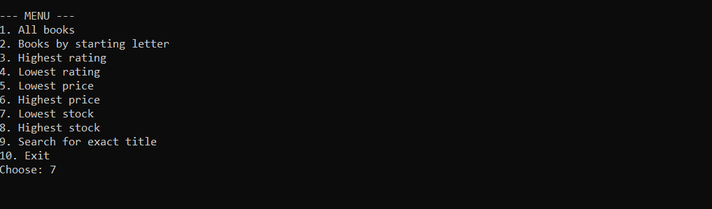( same happens with highest stock feature)
7. Additional Context
- This issue could make people not want to use out app and cause an outrage.

